From robberies to citywide shooting incidents, New York voters are worried not only for their safety but if political leaders will deploy new policies to fix it.

Crime and policing in New York has steadily become a key issue in this upcoming election as the heat turns up as we get closer to November. A recent poll shows that 45% of potential voters find that it is being handled poorly by New York officials, according to the Siena College Research Institute poll in 2022.

Both Democratic Governor Kathy Hochul and Republican opponent, Rep. Lee. Zeldin have both made public safety their top three priorities as they run for the governorship. Zeldin has attacked Hochul, saying in July peace “feels nearly impossible with these backwards laws, policies and politicians stacked against them in favor of criminals.”

“I think for the Republican Party, there is a pretty well-worn path that they’ve taken in the past to just reverting right back to aggressive law and order policing prosecutions and long sentences,” said Lisa Miller, professor of political science at Rutgers University in New Brunswick.

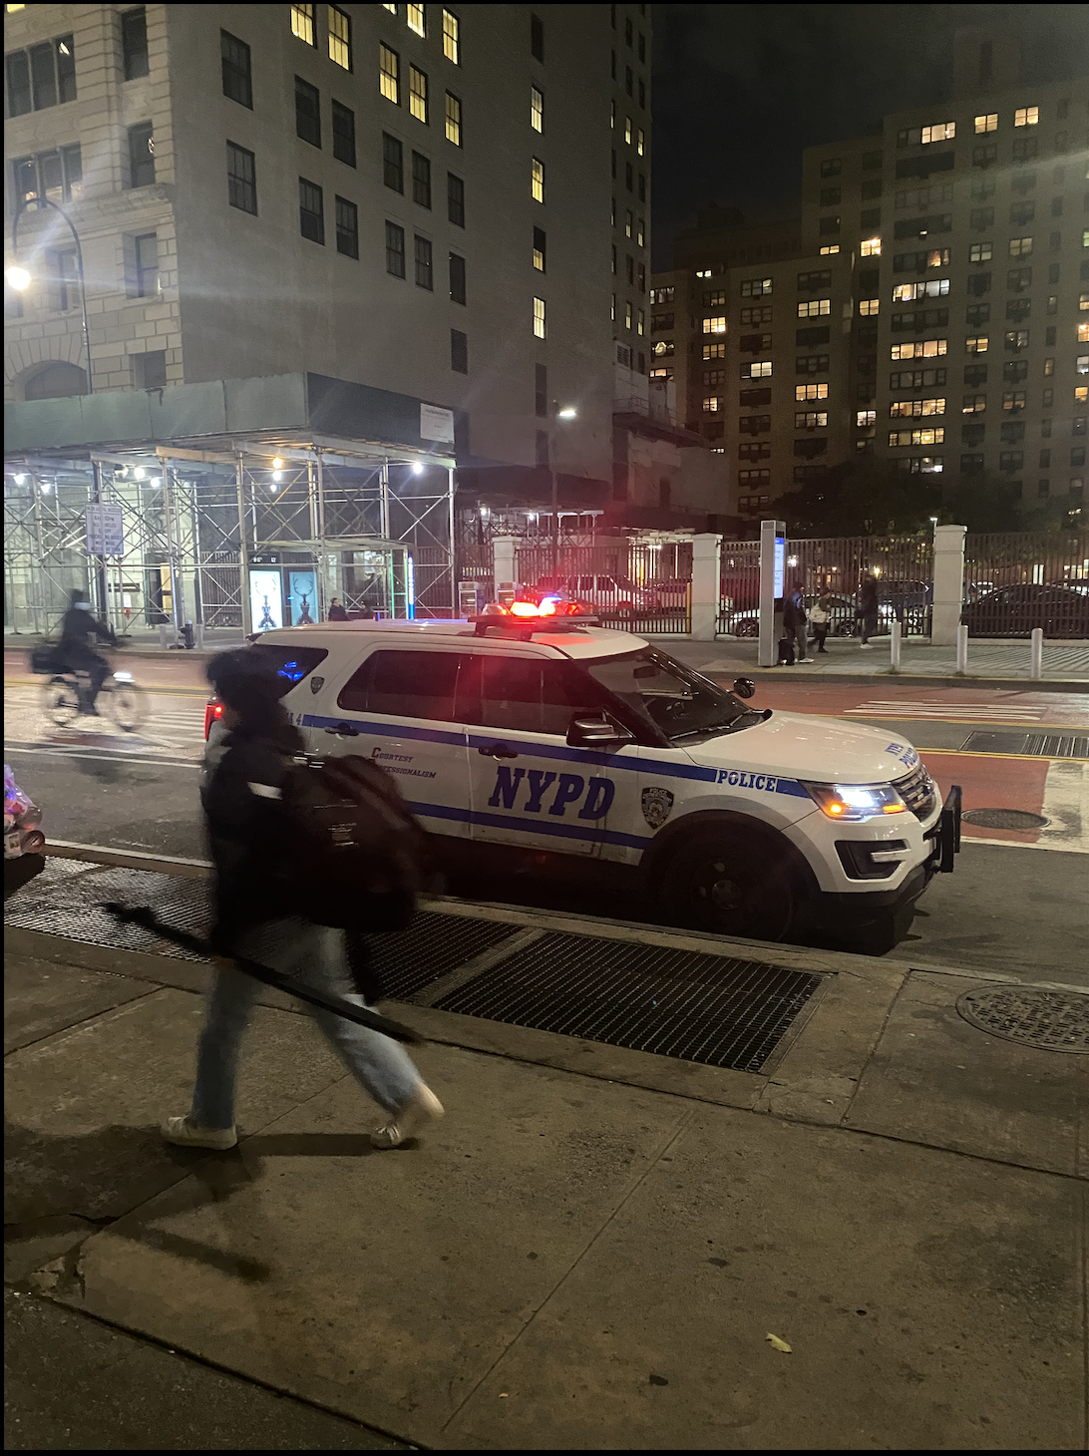
As of August 2022, the overall crime index in New York City has increased by 26% compared to August 2021, according to the New York Police Department Crime Statistics.

We need a transition here…

“They increased cops in the train station to stop people from escaping the fare, yet the cops are nowhere around when crime is happening,” said Kwanza Prince, a 19-year-old student. “I think they are concerned for the state, but I feel they put their energy into things that are unnecessary,”

Other residents, like Prince, say they have experiences with crime causing them to be more cautious in areas like the subways and buses.

“I have definitely seen an increase in crime in subway stations, so I'm more cautious going into subways,” said Isabel Calgaron, a 24-year-old New York resident. “But that doesn’t really deter me or stop things I have to do every day.”

Voters like Calgaron feel as though elected officials could be taking stronger action, rather than offering pledges.

“I think gun safety is very popular and there are a lot of gun safety laws that are very, very widely supported,” said Miller. “And I think the Democrats need to hand this around the Republicans like an albatross.”

Since the pandemic violent crime has only increased over time, according to a crime index released by the NYPD from July 2021 to August 2022.

Voters are worried about their safety but also concerned about whether the candidates are actually hearing what they have to say.

Anna Harvey a professor of politics at New York University expressed in her recent paper “Voting From Jail” the impending need to also allow those in jail equal access to voting and voter registration.

“We wanted to know: are individuals being held in county jails being given the opportunity to exercise their legal right to vote,” said Harvey. “Our findings suggest that the answer is no.”

People incarcerated in jail should still be able to practice their right to vote and without them, a huge population of New York residents who have also had experience with crime and policing in the city is disregarded.

“We need to hold those who are responsible for county jails accountable for ensuring that the incarcerated have the means to exercise their legal right to vote,” said Harvey.

Candidates have a chance to rectify the wrongs and establish a safe environment and community for people who love this city.

“I feel like if our voices were heard more, and there was more community care and community support, then people would feel safer,” said Matt Fitzreid, 27.

Governor Hochul passed the Definition of Firearms bill aimed to define what certain types of firearms are legal under the current Penal Law definitions. Only 1 out of 17 bills the governor has passed is aimed to help aid in public safety and crime in New York.

Kennedy – A much stronger version so keep at it! Please take a look at the restructuring I did and comments. We sort of lost the thread of the story in the bottom half. B+

Contact Information:
Kwana Prince, 19, kp2889@nyu.edu
Isabel Calgaron, 24, iecalgaron@gmail.com
Matt Fitzreid, 27
Lisa L. Miller, miller@polisci.rutgers.edu
Anna Harvey, anna.harvey@nyu.edu

