Dania Castillo was on her way to a concert in April 2022 when an armed man set off smoke grenades and opened fire in a crowded subway train in Brooklyn

“I was like ‘That could never happen to me’ but when I got here the subway shooting happened,” said Castillo, a 19-year-old New York University student. “That’s terrifying you’re in a compartment where you can’t leave.”

Mass shootings in America have become an epidemic and since 2009, there have been 289 mass shootings in the United States including the Colorado Springs shooting that killed five people in an LGBTQ nightclub in November 2022. The surge in violence has led to an increased call to action for politicians to implement gun control laws, with Americans overwhelmingly in favor of gun reform.

“The United States is not the only country with mental illness, domestic violence, or hate-fueled ideologies, but our gun homicide rate is 26 times higher than other high-income countries,” according to Everytown, the largest gun violence prevention organization in America.

“The difference is easy access to guns,” said Everytown. “US states with weaker gun laws and higher gun ownership rates have higher rates of mass shootings.”

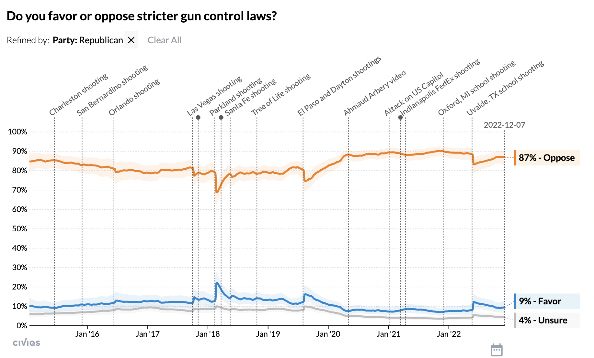
A repetitive cycle has been created due to stagnant political action against gun violence causing more lives to be lost, and leading people like Castillo to repeatedly relive their horrific experiences. This continuation has perpetuated a society that has become desensitized to repeated acts of gun violence.

The vast majority of Republicans (87%) have been opposed to stricter gun control laws since 2015, according to a survey by Civiqs that began asking registered voters after the Charleston church shooting that killed 9 church members in a white supremacy attack.

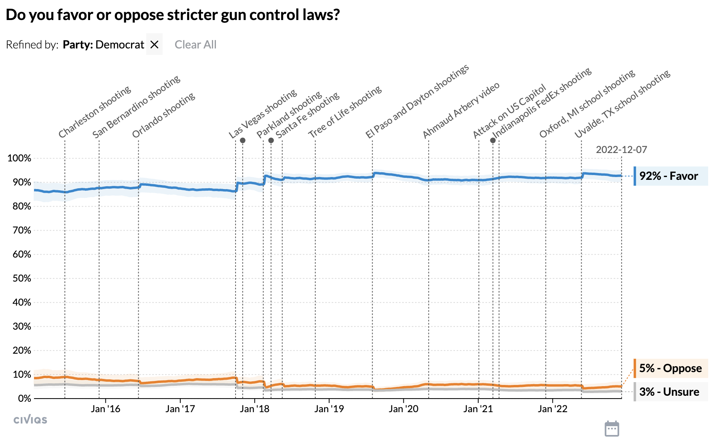
While in the same survey, the majority of Democrats (93%) have been in favor of stricter gun control laws within the same time frame.

Political polarization has played the most significant role in making it harder for any political action to be done based on the Republican minority blocking the progress of gun reform, according to Lisa Miller, professor of political science at Rutgers.

The U.S. has seen increases in affective polarization, a situation in which citizens feel more negatively about other political parties compared to their own, according to the National Bureau of Economic Research.

In 1978, the average partisan rated their party 27.4 points higher than other parties based on a “feeling thermometer”, while in 2020 the average person rated their party 56.3 points higher than the others.

The growing effect of political polarization is ultimately reducing the efficacy of government institutions to create new and safer gun reform policies.

“I would argue that the gun extremists and with the help of the Republican Party, have ushered in an era of just absolute government failure on gun violence,” said Miller. “Their only policy idea is more guns which defy not only research but common sense as well.”

Additionally, previous protections like the federal assault weapons ban, which prohibited the manufacturing or selling of certain semi-automatic weapons for civilian use expired in 2004.

“Gun policy has changed radically but it’s not in the direction of stricter regulations of firearms,” said Dr. Alexandra Filindra, professor of political science and psychology at the University of Illinois Chicago.

For example, in Texas, after the El Paso Walmart shooting where a confessed racist killed 23 people, and a few weeks later 7 people were killed in a shooting spree from Midland to Odessa in 2019, the Texas legislature continued to pass a law where Texas residents could openly carry a handgun without a permit.

An explanation for the continued push for looser gun laws and repealing of previous gun protections by Republican lawmakers can be attributed to the sponsorship by the National Rifle Association (NRA) of the members of the GOP.

Currently, the NRA spends $608,310 on the republican party and candidates like Tommy Tuberville, Ron Johnson and Herschel Walker. And as of this year, the NRA has spent $2,160,000 on support for gun rights.

“The NRA’s direct involvement transitioned into a lobbying organization which formally unleashed it to be not only political directly but also partisan,” said Dr. Filindra. “That created a cycle where more and more Republicans became attuned to the organization’s interests and goals.”

As a result of this cycle and oversaturation of gun violence on social media exposure to this type of violence begs the question, ``Have people become desensitized?”

The trauma around shootings can have a harmful effect on developing minds, and according to the Help Guide, it can also desensitize children to violence and prime them to become violent themselves.

Because of the high number of casualties 1,622 since 2009 alongside the high media coverage, many families around the entire nation are feeling the pain and shock over and over again.

“Because we’re so used to it and because it’s always been run that way it’s not anything new to us,” said Castillo. “That’s the thing we shouldn’t be desensitized to because that’s a pretty awful thing.”

Contact List:
Dania Castillo: 619-597-4332
Lisa Miller: 215-833-6118
Dr. Alexandra Fillindra: 848-218-1943

